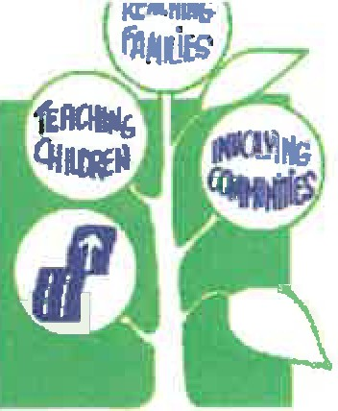Dear Parent,

**WOOD COUNTY HEAD START®, INC.**

1O11 8th Street South · Wisconsin Rapids, WI 54494 Telephone (715) 421-2066 · Fax (715) 421-2069

E-Mail [wchs@woodcoheadstart.org](mailto:wchs@woodcoheadstart.org)

When returning your child's application, please include current documentation of at least one of the following to determine your family's eligibility:

* Current Check Stubs
* Income Tax Form - W2 or 1040
* Proof of SNAP or Childcare Assistance

o You can obtain the appropriate documentation by logging into the MyACCESS App, calling The Northem Income Maintenance Consortium at 1-888-794-5722, or going online to [www.access.wisconsin.gov](http://www.access.wisconsin.gov/)

* Proof of Participation in W-2 Program
* Social Security Documentation
* Foster Care Subsidy/Court Paperwork
* Unemployment Compensation

*\*If you have submitted check stubs or tax information and feel that your family may be over the poverty guidelines followed to determine eligibility, please provide the housing cost information below. Due to new regulations, we are able to adjust a family's annual gross income based on their annual housing costs, allowing families whose housing costs exceed 30% of their income. Please provide costs per a monthly basis.*

* 1. Rent/Mortgage Payment __________ 5. Gas ______
  2. Renter/Homeowner Insurance __
  3. Water ___

1. Electricity ________
2. Sewer ____________
3. Garbage Removal _______

**It is important that we receive this information, as we are unable to process the application without it.**

If you have any questions, please feel free to call us at 715-421-2066 or toll free at 1-866-421-2066.

Sincerely, Fallon Brooks

Family Services Manager Wood County Head Start, Inc

AN EQUAL OPPORTUNITY EMPLOYER